KidsBlock Software

Note: we take the Windows system as an example. As for MacOS system, just follow this instruction.

1. Double click“KidsBlock 1.0.0 Setup.exe”.
2. Select“Anyone who uses this computer(all users)”, then click“Next”.
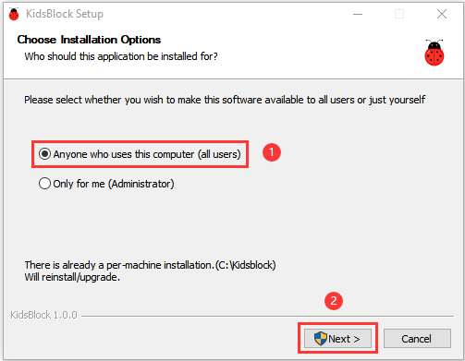
3. Click“Browse...”and choose the Disk where the software will be placed (here, we choose C Drive). Then click“Install”.
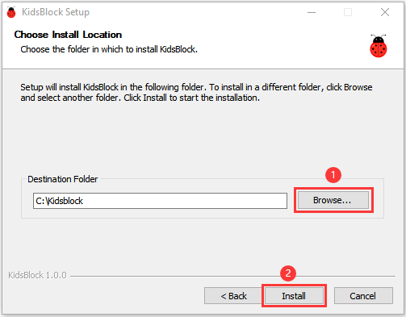
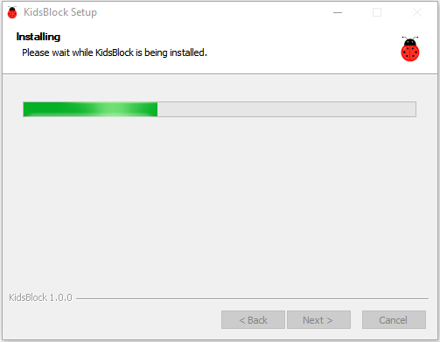
- After a few seconds, the installation is complete.
Click "Finish" to open the installed Kidsblock software.
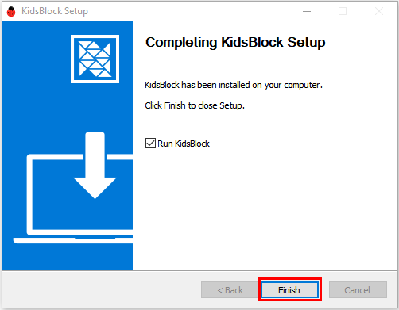
- If the computer security alert window appears, click on“Allow access”.
This is the main page of the Kidsblock software.
